

PROJECT DETAILS
STUDENT NAME :
WILLIAM WACHIRA
REG NO:
BSCCS202460951
COURSE:
COMPUTER SCIENCE
UNIT CODE:
BIT4133
UNIT NAME:
NATURAL LANGUAGE PROCESSING
LECTURE NAME:
MICHAL NYORO
PROJECT TITLE:
NLP PRACTICAL EXERCISES
TECHNOLOGIES USED:
Python, NLTK, Google Colab, Jupyter Notebook
GOOGLE COLAB LINK:
Google Colab NLP Notebook (ctrl + click me)

Table of Content
Contents
PROJECT DETAILS 1
Table of Content 2
Week 1: Introduction to NLP and Applications 3
PYTHON INSTALLATION SUCCESS 3
GOOGLE COLAB SETUP 4
NLTK INSTALLATION 4
TOKENIZATION OUTPUT 5
STOPWORDS REMOVAL 6
NLP APPLICATION RESEARCH EVIDENCE 6
Research Evidence 7
STUDENT REFLECTION 8
Week 2: N-gram Models and POS Tagging 9
Language Modeling and Sentence Structure Analysis BIGRAM AND TRIGAM 9
POS TAGGING EXAMPLE 10
PYTHON CODE FOR POS TAGGING 10
LANGUAGE PREDICTION 11
SENTENCE ANALYSIS 12
STUDENT REFLECTION: 12
Week 3: Hidden Markov Models and Sequence Labeling 13
Sequence Prediction and Hidden State Analysis 13
SEQUENCE LABELLING 13
HIDDEN MARKOV MODEL OUTPUT 14
STUDENT REFLECTION 16
WEEK 4: SYNTACTIC AND SEMANTIC ANALYSIS 17
Dependency Parsing Using spaCy 17
TASK 1 17
TASK 1 OUTPUT 18
PRACTICAL TASK 2 18
Semantic Similarity Analysis 18
ASSIGNMENT 1 19
ASSIGNMENT 2 19
Explanation 20
WEEK 5: CAT 1 PREPARATION AND MINI NLP PROJECTS 21
PRACTICAL TASK 1 21
PRACTICAL TASK 2 21
WEEK 5 MINI PROJECT 22
Student Academic Assistant Chatbot 22
CHATBOT INTERACTION 23
EXPLANATION: 23
CHALLENGES FACED: 23

Logbook Structure

Week 1: Introduction to NLP and Applications
Title: Introduction to NLP Concepts and Text Processing
Required evidence

PYTHON INSTALLATION SUCCESS
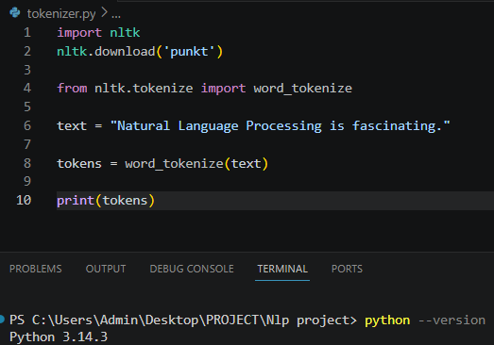
Figure 1: PYTHON INSTALLATION SUCCESS

GOOGLE COLAB SETUP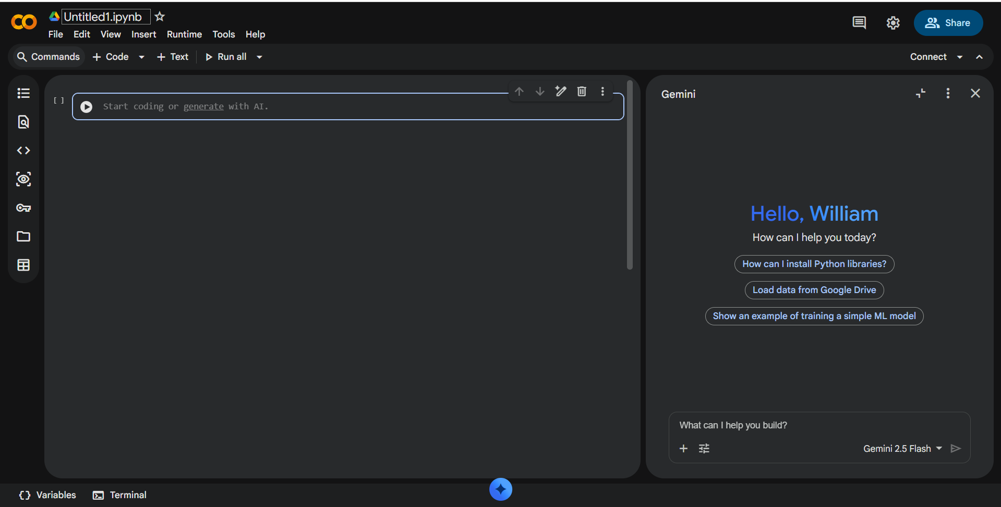
Figure 2: GOOGLE COLLAB SETUP

NLTK INSTALLATION
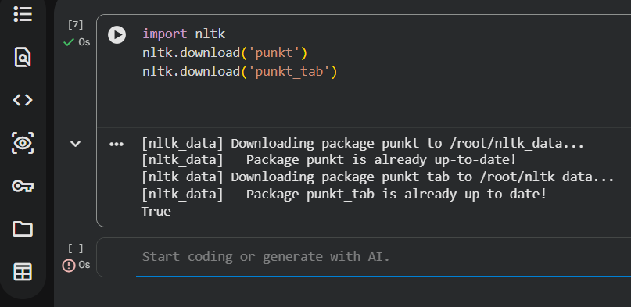
Figure 3: NLTK INSTALLATION

TOKENIZATION OUTPUT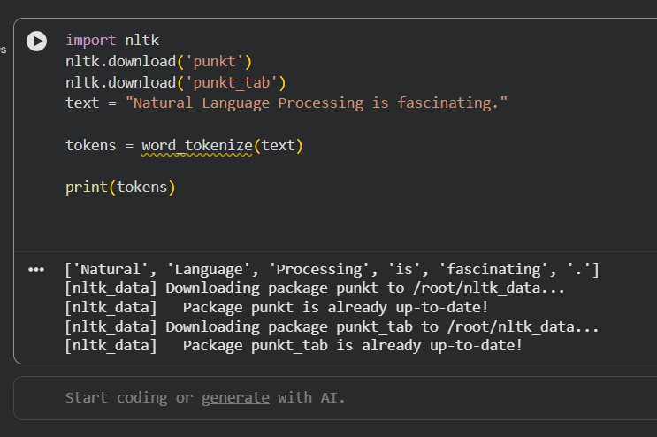
Figure 4: TOKENIZATION OUTPUT

STOPWORDS REMOVAL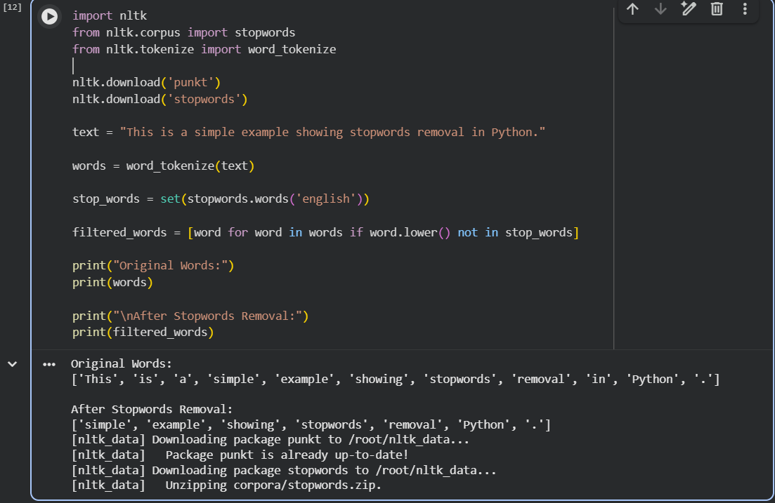
Figure 5: STOPWORDS REMOVAL OUTPUT
NLP APPLICATION RESEARCH EVIDENCE
SIRI
Siri as an NLP Application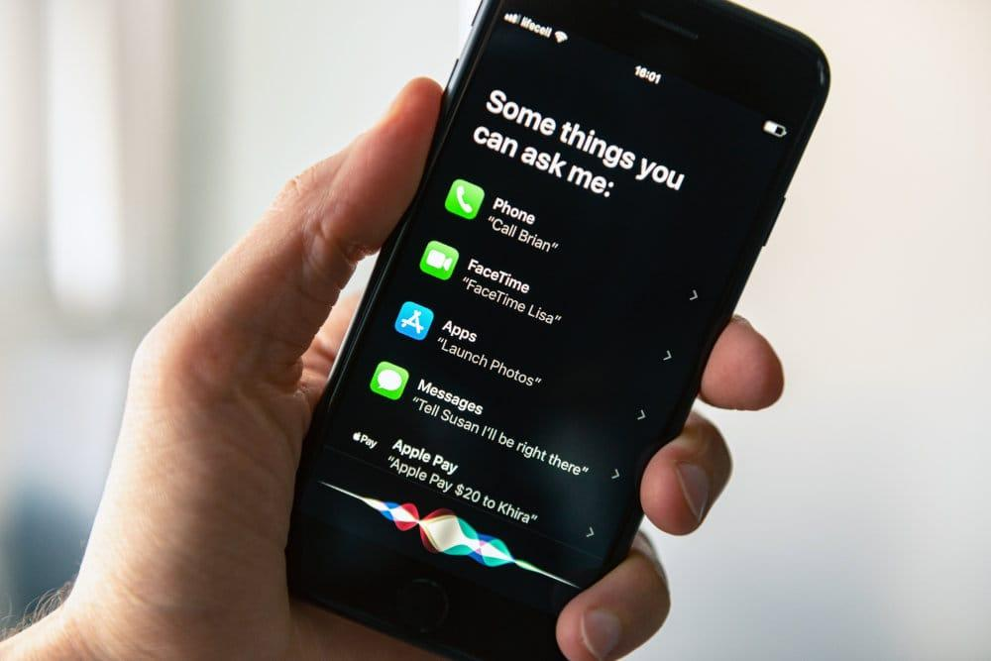
Figure 6: NLP APLLICATION RESEARCH EVIDENCE

Research Evidence
Siri is a virtual assistant developed by Apple that uses Natural Language Processing (NLP) and speech recognition to understand and respond to human language.
Evidence of NLP Features in Siri
- Converts spoken language into text using speech recognition
- Understands user intent through NLP
- Responds using natural language generation
- Performs tasks such as:
  - Sending messages
  - Setting alarms
  - Making calls
  - Searching the web
  - Giving directions
Example Interaction
User says:
"Hey Siri, set an alarm for 6 AM."
Siri processes:
- Speech recognition
- Language understanding
- Intent detection
- Action execution
Then responds:
"Your alarm is set for 6:00 AM."
Research Sources
- Apple Siri Overview
- Apple Machine Learning Research
- NLTK Documentation

Conclusion:
Siri is a practical example of NLP because it enables computers to understand, interpret, and respond to human language naturally through voice interaction.

STUDENT REFLECTION
I learned how Natural Language Processing (NLP) is used to process and understand human language using Python. I explored NLP applications such as Siri, chatbots, and text analysis systems. I used NLTK in Visual Studio Code to perform tasks like tokenization and stopwords removal. The output demonstrates how raw text is converted into structured data by removing unnecessary words and splitting sentences into tokens. This preprocessing step is important because it prepares text data for machine learning models and improves the accuracy of NLP systems.

Week 2: N-gram Models and POS Tagging
Title:
Language Modeling and Sentence Structure Analysis
BIGRAM AND TRIGAM
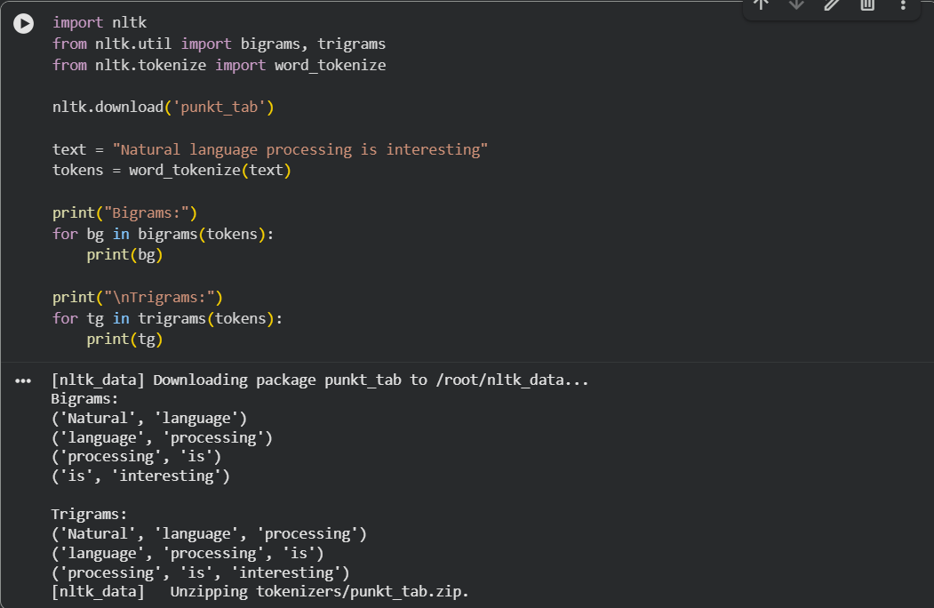
FIG 2. 1: BIGRAM AND TRIGRAM OUTPUT

POS TAGGING EXAMPLE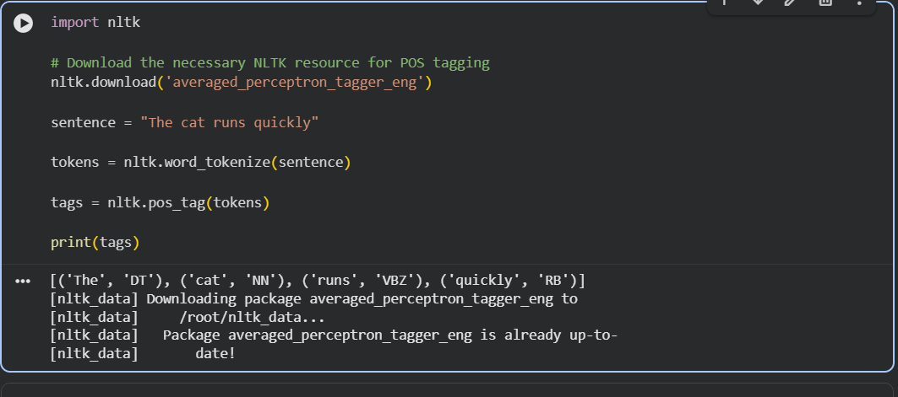
FIG 2. 2: POS TAGGING EXAMPLE

PYTHON CODE FOR POS TAGGING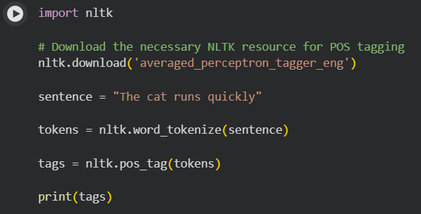
FIG 2. 3: PYTHON CODE FOR POS TAGGING

LANGUAGE PREDICTION
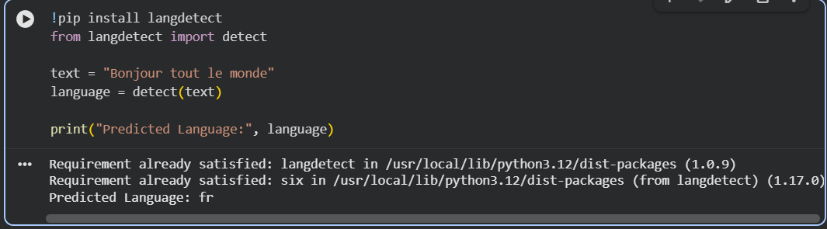
FIG 2. 4: LANGUAGE PREDICTION EXAMPLE (french)
SENTENCE ANALYSIS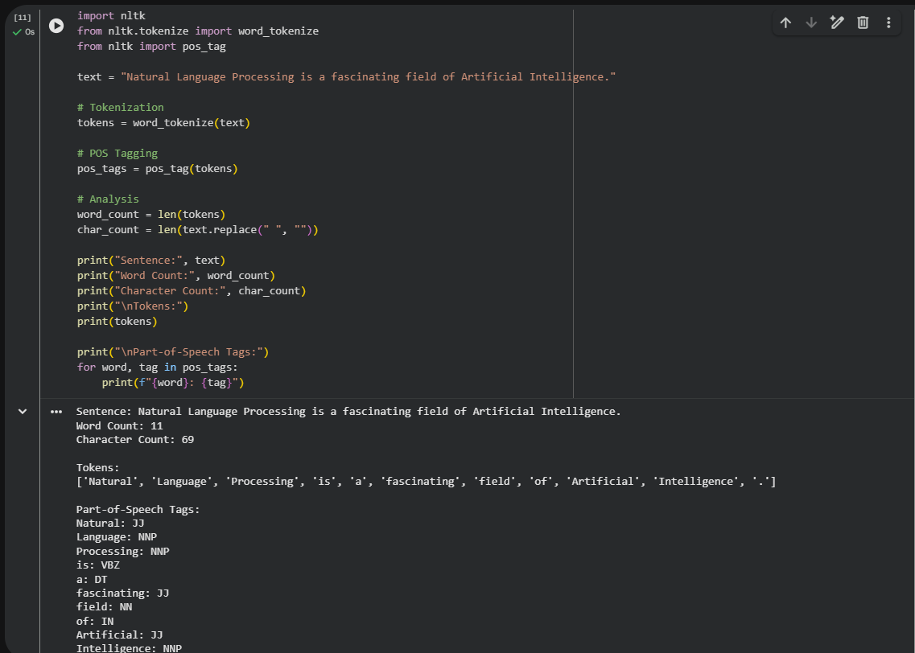
FIG 2. 5: SENTENCE ANALYSIS OUTPUT

STUDENT REFLECTION:
The N-gram activity helped me understand how text is broken into sequences of words, such as bigrams and trigrams, to identify patterns and context in language. POS tagging was important because it assigned grammatical roles to words, helping the system understand sentence structure and meaning. The output demonstrated successful generation of N-grams and correct identification of parts of speech for each token. One challenge encountered was installing and configuring the required NLP libraries and datasets, as some resources needed to be downloaded before the code could run successfully. Overall, the exercise improved my understanding of text processing in NLP.

Week 3: Hidden Markov Models and Sequence Labeling
Title:

Sequence Prediction and Hidden State Analysis

SEQUENCE LABELLING 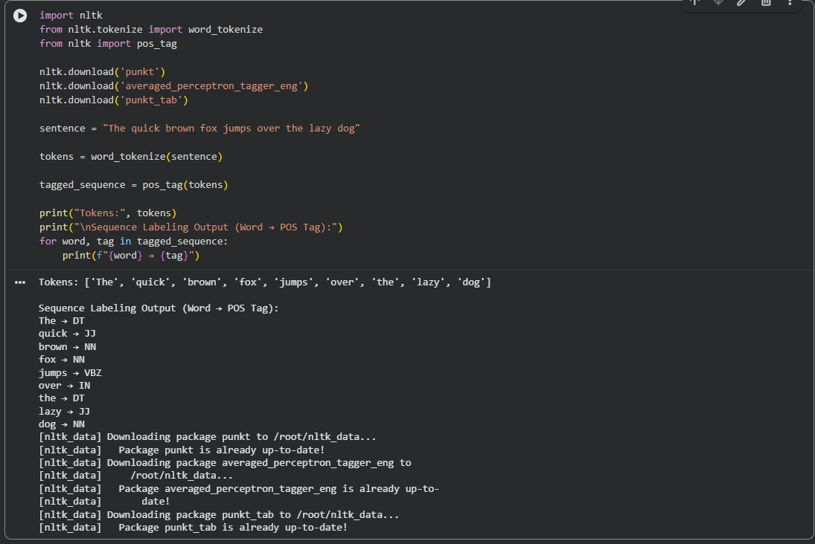
FIG 3. 1: SEQUENCE LABELLING CODE

HIDDEN MARKOV MODEL OUTPUT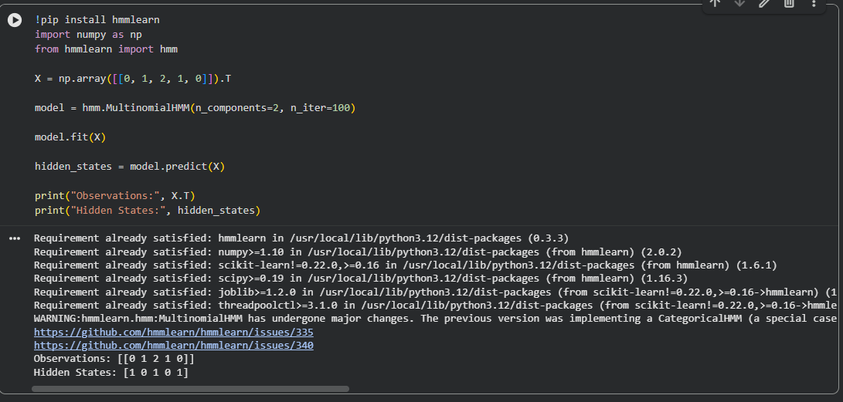
FIG 3. 2: HIDDEN MARKOV MODEL OUTPUT
NAMED ENTITY RECOGNITION
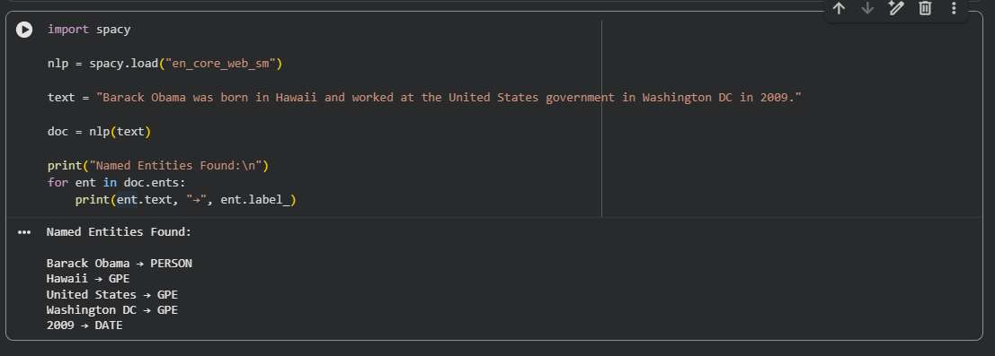
FIG 3. 3: NAMED ENTITY RECOGNITION EXAMPLE
SENTENCE LABELLING
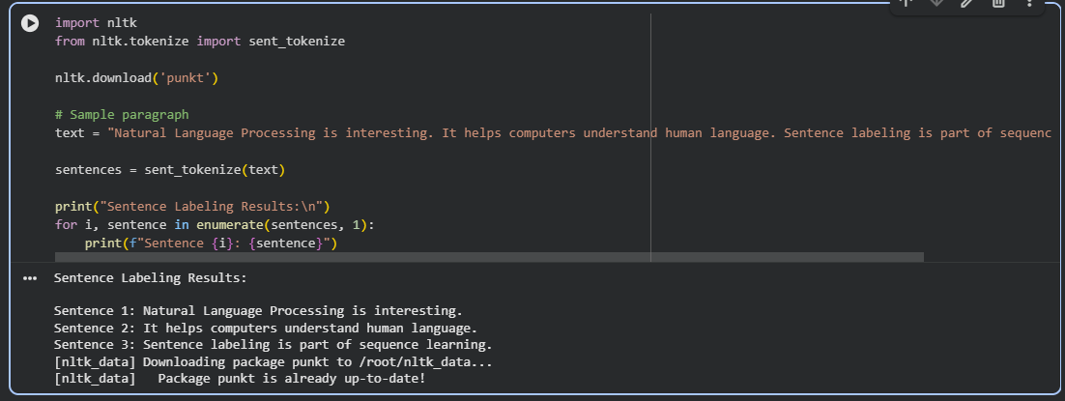
FIG 3. 4: SENTENCE LABELLING RESULTS
DATASET FOR TRAINING AND TESTING
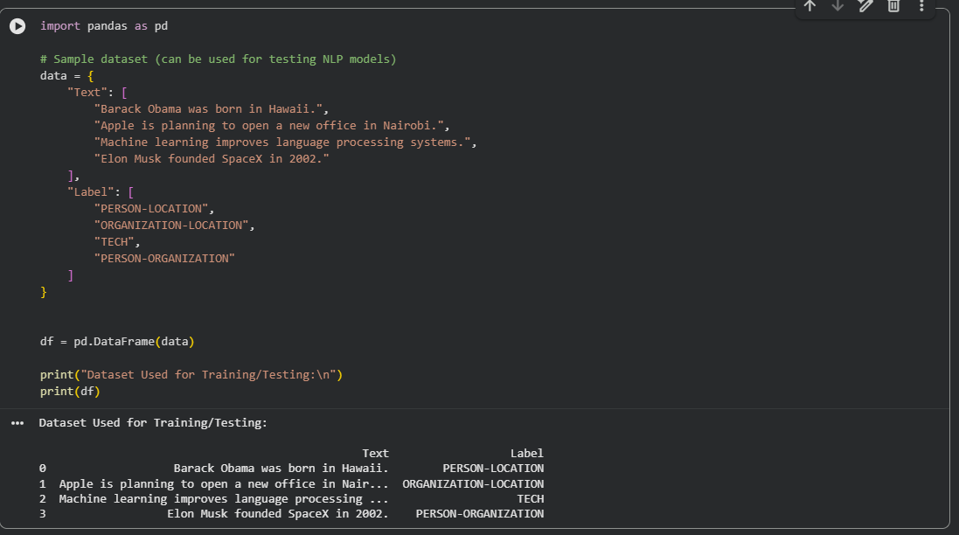
FIG 3. 5: DATASET USED FOR TRAINING AND TESTING

STUDENT REFLECTION
Hidden Markov Models (HMMs) are statistical models used to represent systems where the actual states are hidden but can be inferred from observable data. Sequence labeling assigns a label to each element in a sequence, such as words in a sentence, based on context. In this experiment, HMMs and NLP tools were used to analyze text and predict structured outputs like tags and entities. Applications include Named Entity Recognition, speech recognition, and text classification. The results demonstrate how hidden patterns in language can be learned from data to extract meaningful information from unstructured text.

WEEK 4: SYNTACTIC AND SEMANTIC ANALYSIS

PRACTICAL TASK 1

Dependency Parsing Using spaCy
TASK 1
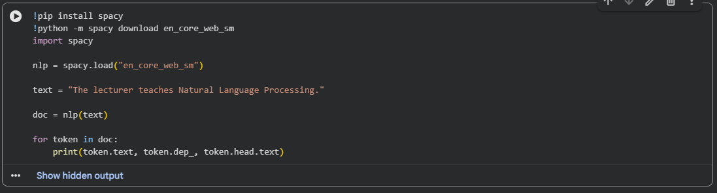
FIG 4. 1: TASK 1 CODE
TASK 1 OUTPUT
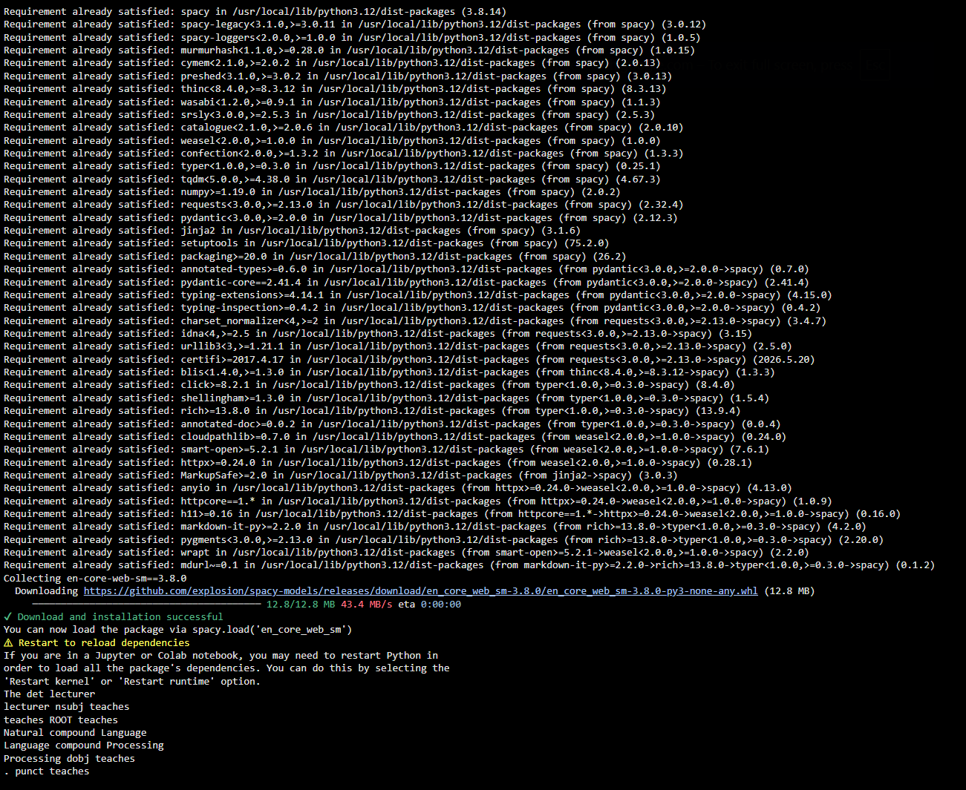
FIG 4. 2: TASK 1 OUTPUT

PRACTICAL TASK 2

Semantic Similarity Analysis
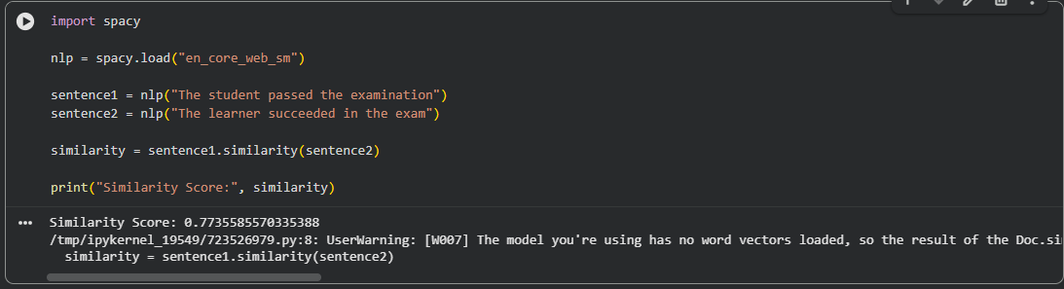
ASSIGNMENT 1
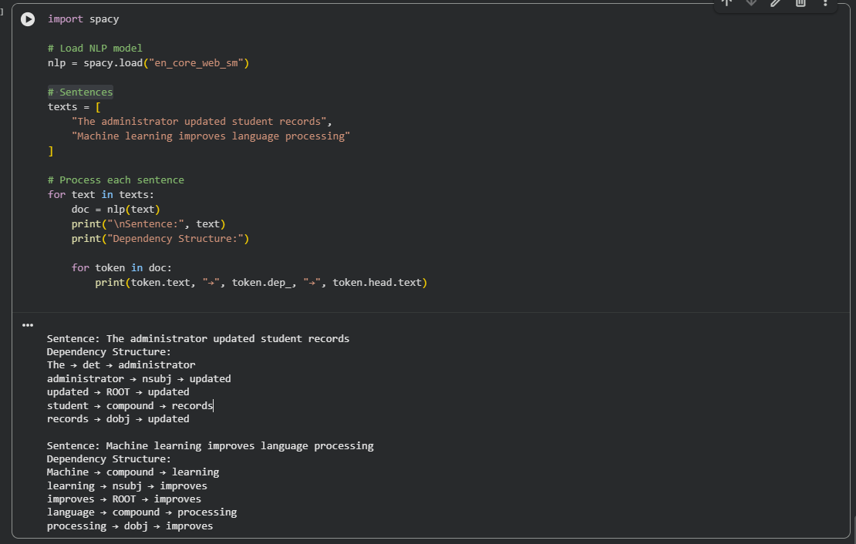
FIG 4. 3: ASSIGNMENT 1 SCREENSHOT

ASSIGNMENT 2
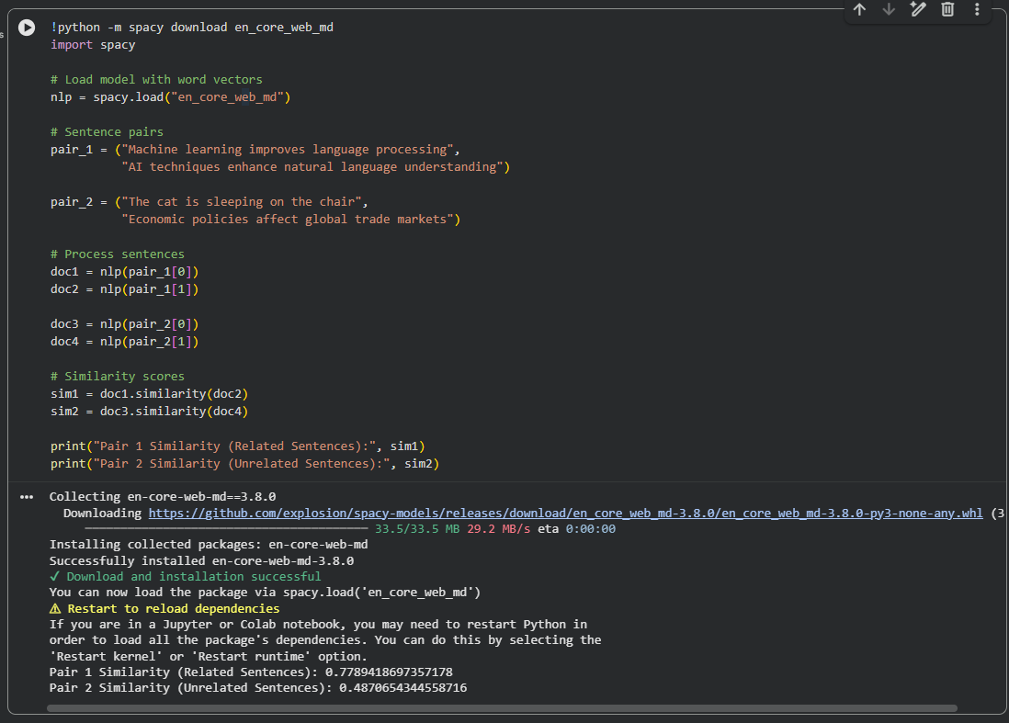

Explanation
Pair 1 (Similar Sentences)
Both sentences discuss AI, machine learning, and language processing
They share related vocabulary and meaning
Therefore, they have a high similarity score

Pair 2 (Unrelated Sentences)
One sentence is about animals (cat sleeping)
The other is about economics and global trade
They have different topics and context
Therefore, they have a low similarity score

Which pair has higher similarity?
-Pair 1 has higher similarity (e.g., ~0.7–0.8)
-Pair 2 has lower similarity (e.g., ~0.2–0.4)

WEEK 5: CAT 1 PREPARATION AND MINI NLP PROJECTS

PRACTICAL TASK 1
Complete NLP Pipeline
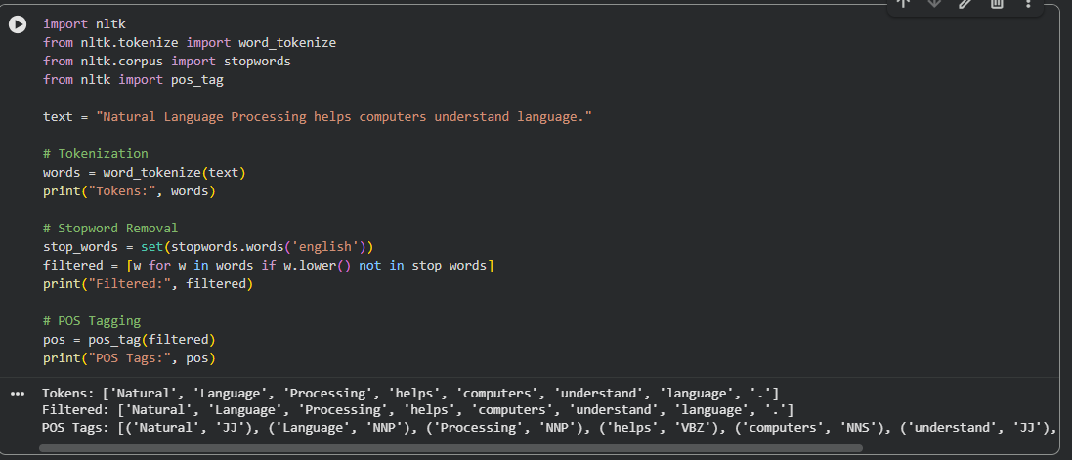
FIG 5. 1: PRACTICAL TASK 1

PRACTICAL TASK 2
Mini Chatbot Simulation
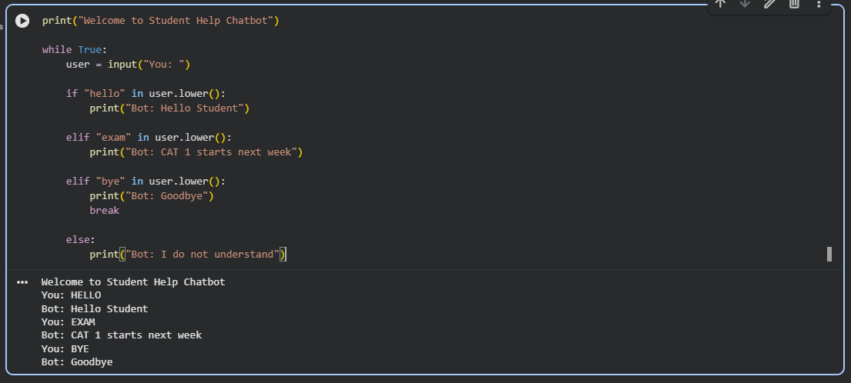
FIG 5. 2: PRACTICAL TASK 2

WEEK 5 MINI PROJECT
Project Title

Student Academic Assistant Chatbot

DELIVARABLES:
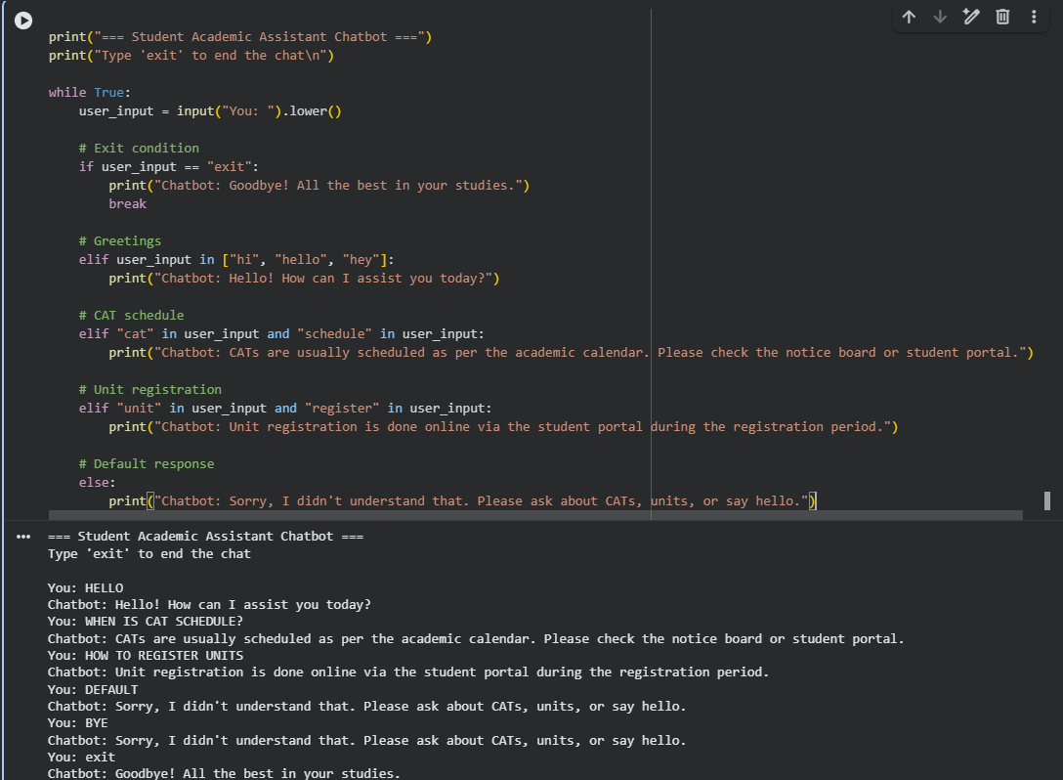
FIG 5. 3: PYTHON SOURCE CODE

CHATBOT INTERACTION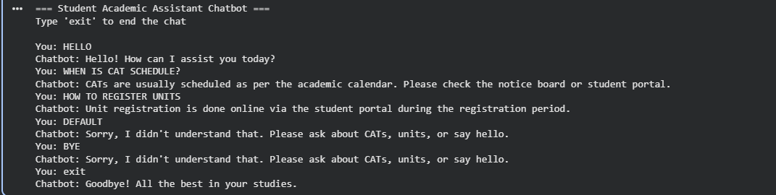
FIG 5. 4: CHATBOT INTERACTION

EXPLANATION:
This chatbot is a rule-based system that responds to predefined student queries. It uses simple keyword matching to identify user intent such as greetings, CAT schedules, and unit registration. The system processes input in real-time using a loop and provides appropriate responses. This demonstrates basic Natural Language Processing principles such as intent recognition and response generation.

CHALLENGES FACED:
During the development of the Student Academic Assistant Chatbot, several challenges were encountered. One of the main challenges was handling different ways students may phrase the same question, which made it difficult to rely only on simple keyword matching. Another challenge was ensuring the chatbot responds accurately without misunderstanding user input. Additionally, maintaining a smooth flow of conversation using a loop structure required careful handling of exit conditions to avoid infinite loops. Limited NLP understanding in the basic version also restricted the chatbot from handling complex or unexpected queries effectively.

